**Learning Steps: -**

1. Reading Corda Key Concepts from documentation.

<https://docs.corda.net>

1. Refresher on Java programming.
2. Code reading from POC’s (PNC, Security lending).
3. Corda Java Bootcamp course from Corda YouTube channel.

<https://www.youtube.com/watch?v=CKRfVlwRl2M&list=PLi1PppB3-YrVq5Qy_RM9Qidq0eh-nL11N>

1. Trade-Finance POC on Corda platform.

**Demo: -**

1. Corda Bootcamp: TokenIssue.

Nodes: - 3

1. Issuer.
2. Owner.
3. Notary.
4. Trade-Finance:

Trade-Finance: -

A seller (or [exporter](https://en.wikipedia.org/wiki/Exporter)) can require the purchaser (an [importer](https://en.wikipedia.org/wiki/Importer)) to prepay for goods [shipped](https://en.wikipedia.org/wiki/Shipping), the purchaser (importer) may wish to reduce risk by requiring the seller to document the goods that have been shipped. [Banks](https://en.wikipedia.org/wiki/Bank) may assist by providing various forms of support. For example, the importer's bank may provide a [letter of credit](https://en.wikipedia.org/wiki/Letter_of_credit) to the exporter (or the exporter's bank) providing for payment upon presentation of certain documents, such as a [bill of lading](https://en.wikipedia.org/wiki/Bill_of_lading). The exporter's bank may make a loan (by advancing funds) to the exporter on the basis of the export contract.

**Letter of credit(LOC):** Letter of credit is a letter issued by a bank to another bank (especially one in a different country) to serve as a guarantee for payments made to a specified person under specified conditions. (Bank's promise to pay an exporter upon presentation of documentary proof of

goods having been shipped.)

**Bill of Lading(BOL):** A bill of lading is a legal document between a shipper(Exporter) and a carrier that details the type, quantity and destination of the goods being carried. [The bill of lading](https://www.investopedia.com/video/play/bill-lading/) also serves as a shipment receipt when the carrier delivers the goods at the predetermined destination.

Setup: 5 Participant, 1 Notary.

1. PartyA – Importer.
2. PartyB – Exporter
3. PartyC – ImportersBank
4. PartyD – ExportersBank
5. PartyE – Carrier.
6. Notary.

Steps: -

1. Importer requests goods from the exporter in exchange of money. (i.e. Trade agreement).
2. Exporter accepts the trade agreement.
3. Importer asks its bank for LOC in favor of the exporter.
4. The importer's bank supplies LOC in favor of the exporter.
5. Exporter prepares a shipment and hands it off to the carrier and creates BOL.
6. The exporter's bank claims half the payment from the importer's bank.
7. The importer's bank transfers half the amount to the exporter's bank.
8. The carrier ships the goods to the destination.
9. The importer's bank pays the remaining amount to the exporter's bank.
10. **Trade Agreement.**

**Participant**: Importer, Exporter.

**State**: TradeAgreementState

**Contract**: TradeAgreementContract.

**Flow**: a. TradeAgreementFlow. (By Importer)

**b**. AcceptAgreementFlow (By Exporter).

2. **Letter of Credit.**

**Participant**: Importer, Exporter, ImportersBank, ExportersBank.

**State**: LetterOfCreditState.

**Contract**: LetterOfCreditContract.

**Flow**: a. ApplyForLocFlow (By Importer)

**b**. IssueLocFlow (By ImportersBank).

3. **Bill of Lading.**

**Participant**: Importer, Exporter, ImportersBank, ExportersBank, Carrier.

**State**: BillOfLadingState.

**Contract**: BillOfLadingContract.

**Flow**: a. CreateBolFlow (By Exporter)

**Key Points: -**

**Flow:**

1. Extends FlowLogic.
2. Override ProgressTracker and call methods.
3. @InitiatingFlow
4. @InititedFlow (Responder Flow)
5. Steps: - (In call method).
6. Get Notary from ServiceHub MapCache.
7. Get OurOwnIdentity. (Initiator of flow/transaction).
8. Get Input State from Vault. (If required).
9. Create Output state.
10. Create Transaction builder.
11. Add Input state to transaction. (If required).
12. Add Output State to Transaction.
13. Add command with signer’s key to Transaction.
14. Verify the build transaction (Here Contract verifies the conditions).
15. Sign the Initial transaction.
16. Call the Finality sub flow to commit transaction.

**Contract:**

1. Implements Contract.
2. Override verify method.
3. Declare commands.
4. Steps: (In Verify Method).
5. Verify Number of Input States.
6. Verify number of Output States.
7. Verify commands.
8. Verify required signers.
9. Other functionality/verification.

**States:**

1. Implements ContractState.
2. Override getParticipants method.
3. Declare required fields.

**How to debug Cordapp: -**

Attach the debugger to the node of interest on its debug port:

* Debug port of parties.

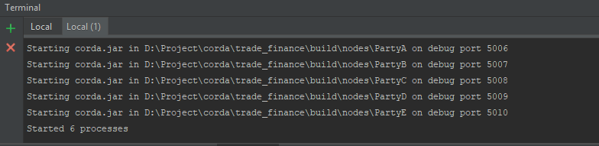

* In IntelliJ IDEA, create a new run/debug configuration of type Remote.

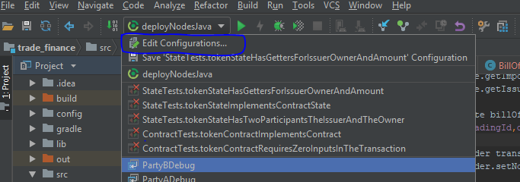

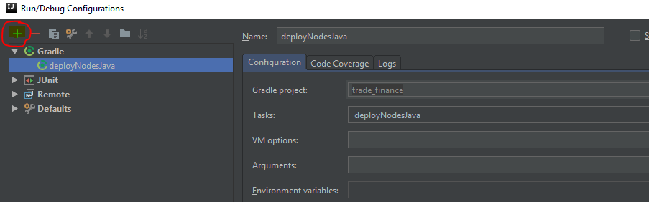

* Set the run/debug configuration’s Port to the debug port

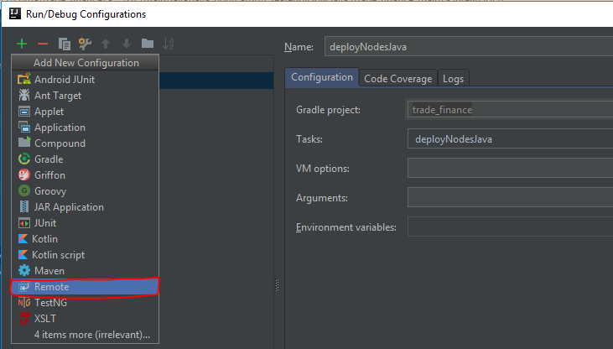

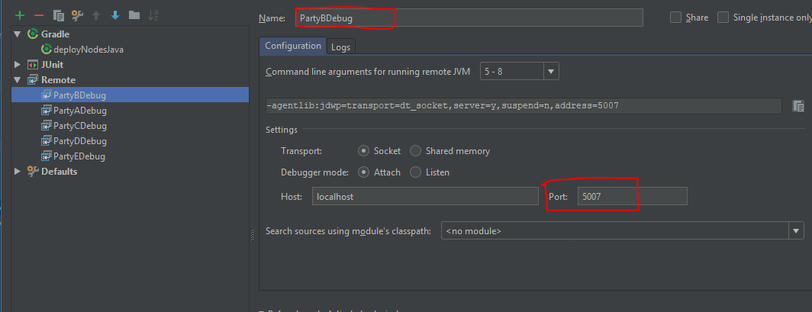

* Start the run/debug configuration in debug mode.

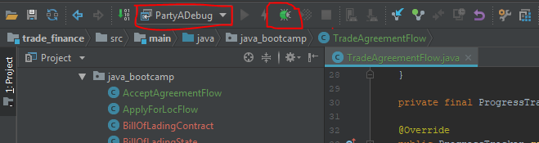

* Select the Flow and Add a breakpoint.

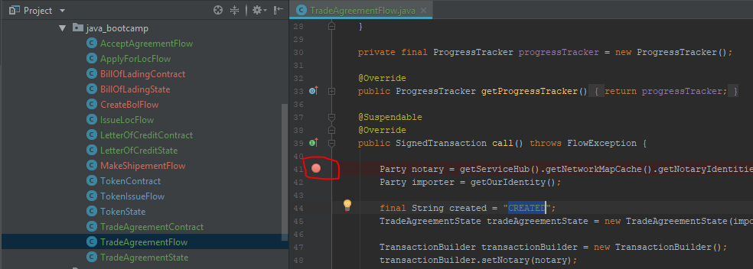

* Initiate flow.

